Website + SEO/GEO Self‑Assessment Worksheet
Instructions: Review your website or main digital home base (website, or existing digital homebase, digital company profile). Use the checklist below to evaluate how easy it is for international buyers and search engines to understand your business. Tick the items that are already strong and note areas that need improvement.

Checklist: Website + SEO/GEO Key Success Factors
- ☐ Clear headline explaining what the business sells
- ☐ Products categorized simply and logically
- ☐ High‑quality but lightweight images
- ☐ Country of origin clearly visible
- ☐ Certifications or standards shown where relevant
- ☐ Sustainability claims explained concretely (not vague)
- ☐ WhatsApp, contact form, or email clearly visible
- ☐ Export or business contact information included
- ☐ Fast, simple, uncluttered website design

Quick Evaluation
How many items did you check? ______ / 9
What is the strongest element of your website today?
__________________________________________________________
__________________________________________________________

Identify One Key Improvement
What is the most urgent improvement needed for your website or digital home base?
__________________________________________________________
__________________________________________________________

Keyword Strategy for one product or service
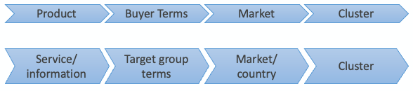
For your most important product or service write down the:
- Product/ Service
- Buyer terms
- Markets
- Keyword Clusters
PRODUCT:

BUYER TERMS:

MARKETS:

At least 3 KEYWORD CLUSTERS:

Frequently Asked Questions
Write down at least 3 questions your potential website visitor could ask related to your most important product.

